HTML Assignment:

NAME :Gummadi Bhavya Sri

1. Question:

The CSS Box Model is a fundamental concept in web design that describes the layout and design of elements on a webpage. It essentially conceptualizes every element on a webpage as a rectangular box, which consists of several parts: content, padding, border, and margin. The CSS Box Model affects the layout of elements on a webpage by influencing the spacing and positioning of elements relative to each other. By adjusting the padding, border, and margin properties, you can control the spacing between elements, create visual separation, and influence the overall structure and design of the webpage.

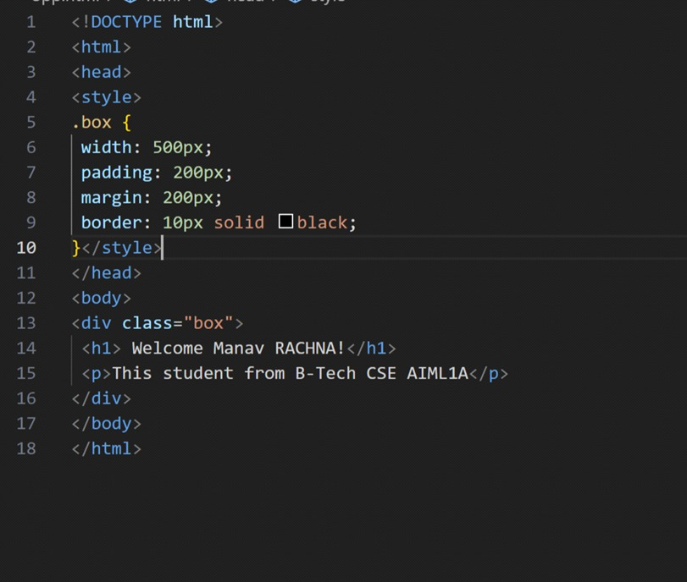

OUTPUT:

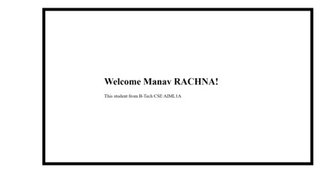

2. Question:

CSS specificity is a crucial concept in web development that determines which style rules are applied to an element when multiple conflicting CSS rules exist. Specificity is used to decide which style should take precedence when multiple CSS rules target the same element. The specificity of a CSS selector is determined by the combination of the following factors:

a. Inline styles: Inline styles have the highest specificity. Styles applied directly to an element using the style attribute will always take precedence over other CSS rules.

b. ID selectors: ID selectors have a higher specificity compared to class selectors and element selectors. They are denoted by the "#" symbol followed by the ID name.

c. Class selectors, attribute selectors, and pseudo-classes: These have a medium specificity. They are denoted by the "." symbol for classes and can also include attributes and pseudo-classes.

d. Element selectors: These have the lowest specificity and target elements based on their tag names, such as div, p, or span. By understanding how specificity is calculated, developers can write more efficient and predictable CSS code. They can use specific selectors when necessary and avoid overusing inline styles, which can lead to maintenance issues and make the CSS harder to manage. Understanding specificity is important for creating maintainable, scalable, and well-structured CSS codebases for web pages.

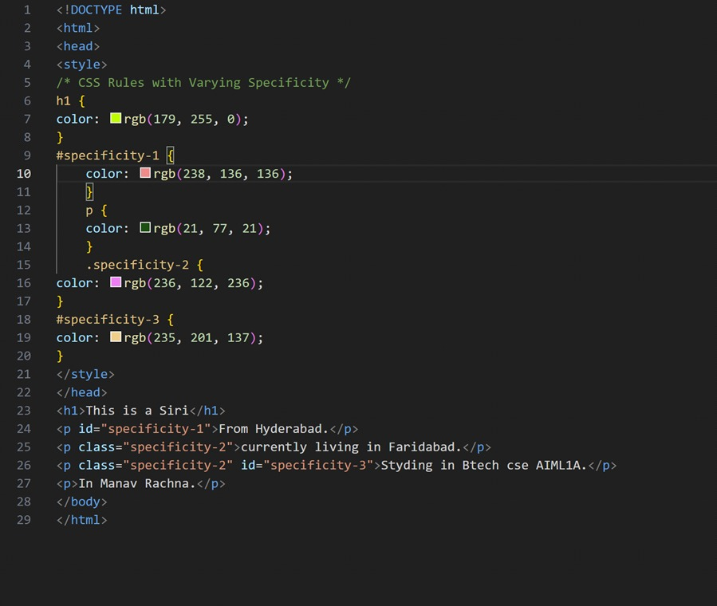

OUTPUT:

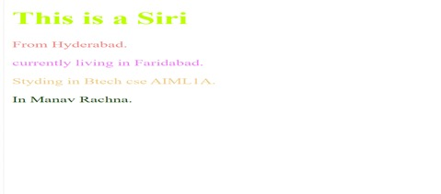

3. Question:

CSS Flexbox and CSS Grid are two powerful layout models in CSS that allow developers to create complex and responsive layouts for web pages. Although they both serve similar purposes, they have different use cases and are suited for different layout requirements.

1. CSS Flexbox: CSS Flexbox is designed for one-dimensional layouts, either in a row or a column. It provides a more efficient way to align and distribute space among items in a container, even when their size is unknown or dynamic.

2. CSS Grid: CSS Grid is a two-dimensional layout system that allows you to create complex grid-based layouts with rows and columns. It provides precisecontrol over both the rows and columns, making it ideal for creating complex and intricate layouts, such as website layouts, image galleries, and any design that requires a structured grid. Here's a simple example of a CSS Grid layout:

A)

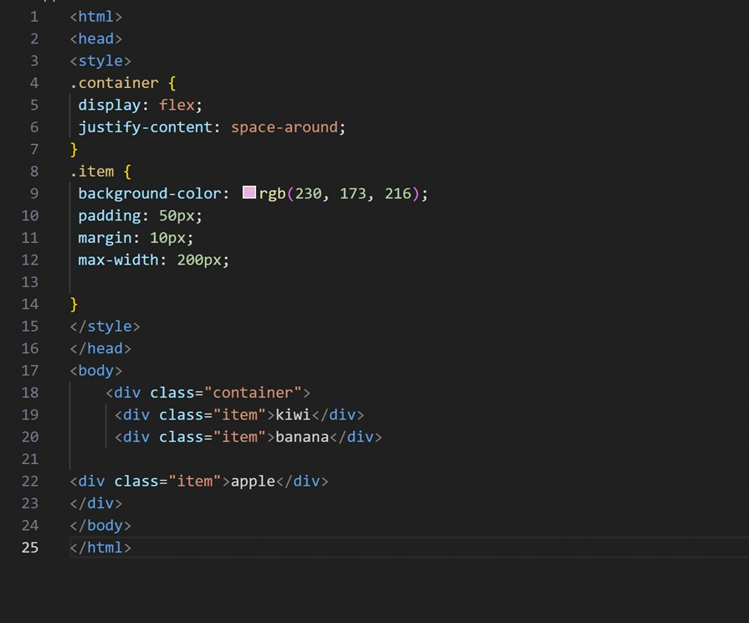

B)

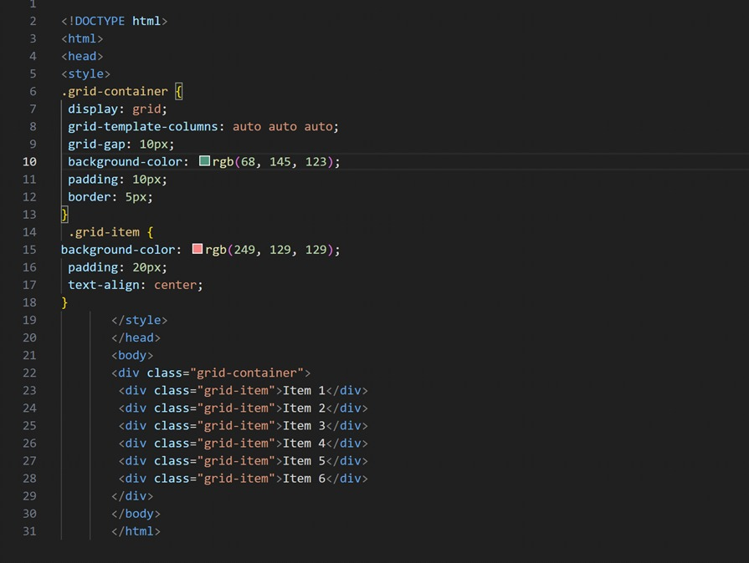

OUTPUT

A)

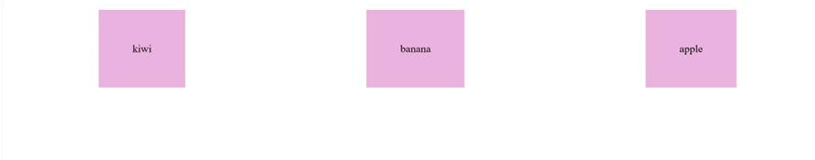

B)

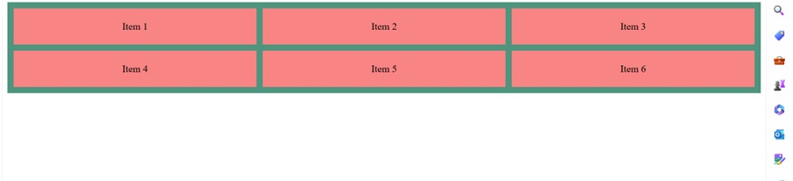

4. Question:

position: relative:

a. When an element is set to position: relative, it is positioned relative to

its normal position within the document flow.

b. This means that the element remains in the flow of the document, and

other elements are positioned as if it were still in its normal position.

c. Use position: relative when you want to adjust an element's position

relative to its normal position without affecting the layout of other

elements.

position: absolute:

d. With position: absolute, the element is positioned relative to its nearest

positioned ancestor (an ancestor that is not static) or to the initial

containing block if there is no positioned ancestor.

e. The element is removed from the normal document flow, and other

elements are positioned as if it were not there.

f. Use position: absolute when you need to position an element precisely

in relation to its closest positioned ancestor, often used for creating

overlays, dropdowns, and tooltips.

position: fixed:

g. Setting an element to position: fixed positions it relative to the

browser window or the viewport.

h. The element remains fixed in its position even when the page is

scrolled, making it suitable for elements such as navigation bars,

headers, or footers that need to remain visible regardless of the scroll

position.

i. Use position: fixed when you want an element to remain in the same

position relative to the viewport, ensuring it stays visible and accessible

while the user scrolls through the content.

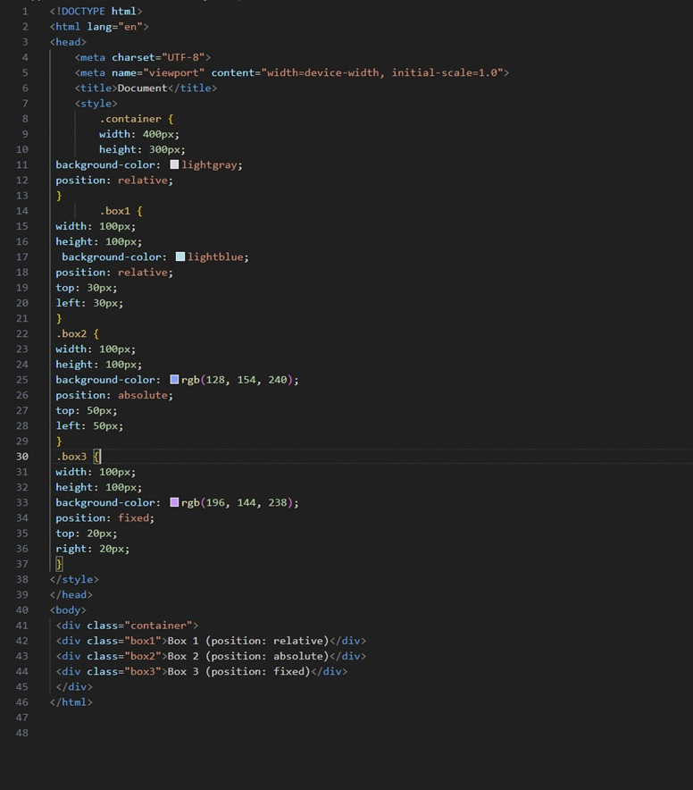

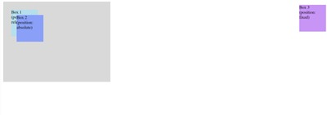

5.Question :

::before: This pseudo-element inserts content before the content of the selected element. It is often used to add decorative elements or textual content before an element. ::after: This pseudo-element inserts content after the content of the selected element. It is commonly used to add decorative elements, icons, or additional styling effects after an element.

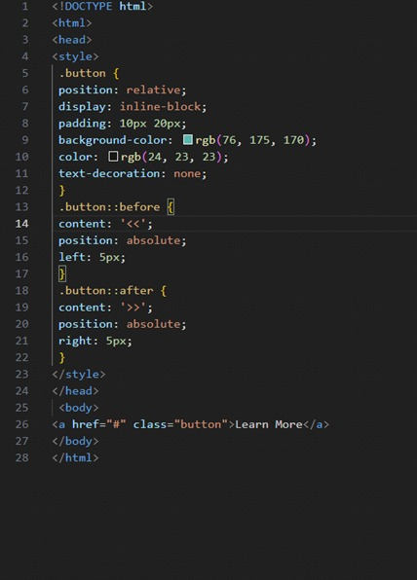

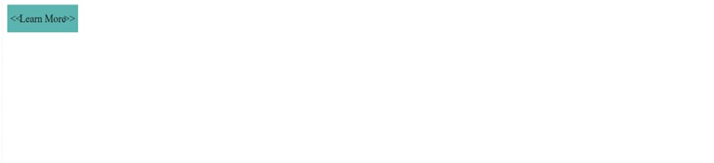

OUTPUT:

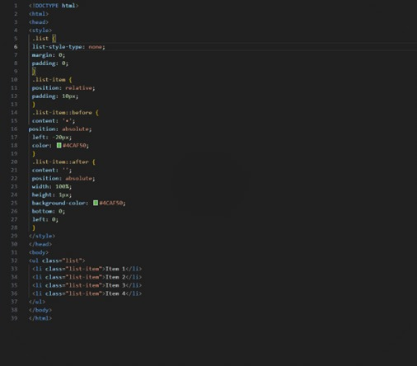

OUTPUT:

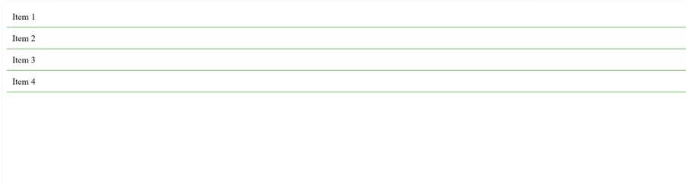

6.Responsive web design is an approach to web development that aims to create

websites that provide an optimal viewing experience across a wide range of

devices and screen sizes. The goal is to ensure that the content and layout of a

webpage can adapt and respond to the user's device, whether it's a desktop,

tablet, or smartphone. Media queries are a key component of responsive web design that allow developers to apply different styles based on the characteristics of the device and the browser.

They enable the adaptation of the layout and design based on factors such as screen size, resolution, and orientation. Media queries use CSS rules to specify different styles for different conditions, ensuring that the webpage layout adjusts dynamically to provide an optimal viewing experience on various devices. Here's an example of how media queries can be used to create a responsive webpage:

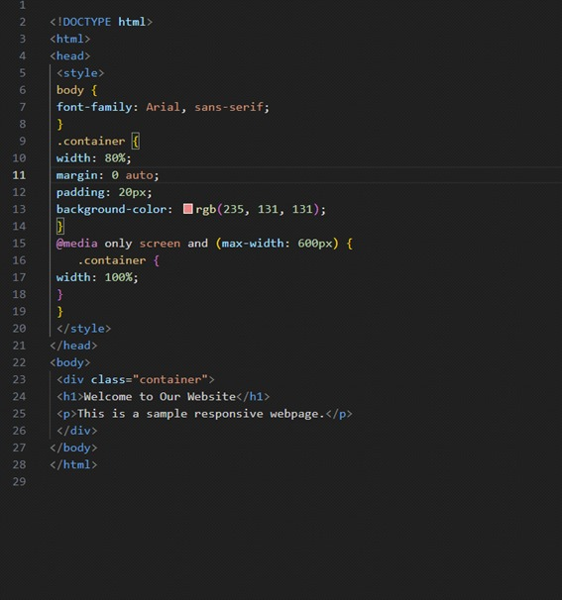

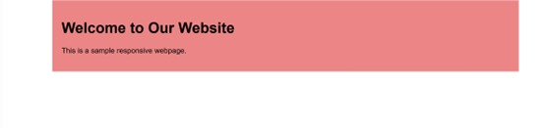

EXERSCISE:

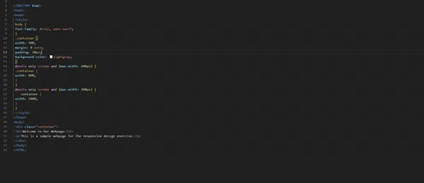

OUTPUT:



7.Question :

Accessibility in web development is crucial for ensuring that websites and web applications are usable and accessible to all users, including those with disabilities. It involves designing and developing digital content in a way that accommodates various impairments and disabilities, such as visual, auditory, motor, or cognitive impairments. By making web content accessible, developers can ensure that everyone, regardless of their abilities, can perceive, understand, navigate, and interact with the content effectively.

ARIA (Accessible Rich Internet Applications) roles and attributes are a set of attributes defined by the W3C that can be added to HTML elements toimprove the accessibility of web content for users with disabilities. ARI Aroles and attributes help assistive technologies, such as screen readers,interpret and convey the functionality and information of web elements to users, enabling a more accessible and inclusive user experience. Here's an example of how to make a webpage more accessible using ARIA roles and attributes:

EXERCISE:

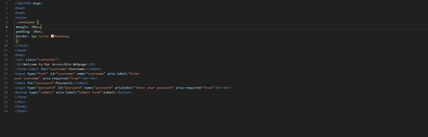

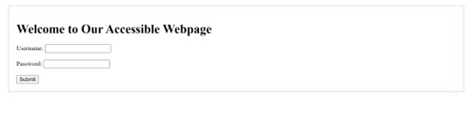

8.Question :

The <!DOCTYPE> declaration in HTML (Hypertext Markup Language) is used to specifythe version of HTML or XHTML that a web document is using. It serves as an instruction to web browsers and other software about how to interpret the markup of the document. The purpose of the <!DOCTYPE> declaration is to ensure that the web document is displayed correctly and consistently across different web browsers. Different web browsers have their own rendering engines, which interpret HTML and CSS to display web content. The presence of a correct and valid <!DOCTYPE>declaration ensures that the browser renders the webpage in standards-compliantmode, following the specified rules and standards for the declared version of HTML or XHTML. This helps maintain consistency and predictability in how the webpage is displayed across different browsers and devices.

A.

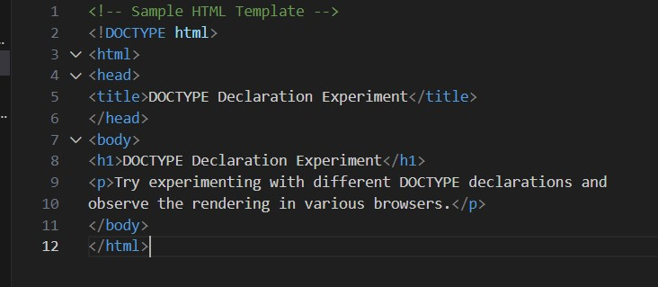

B.

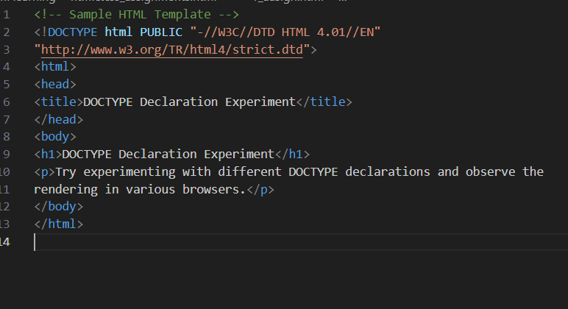

C.



D.

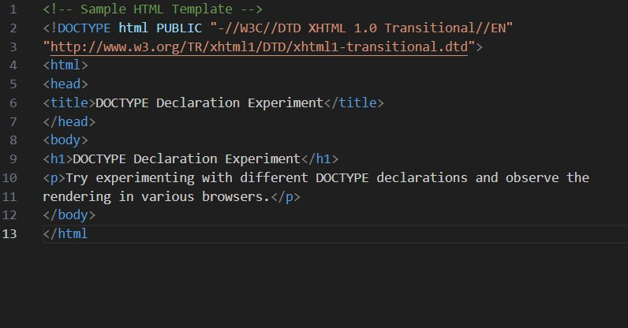

E.

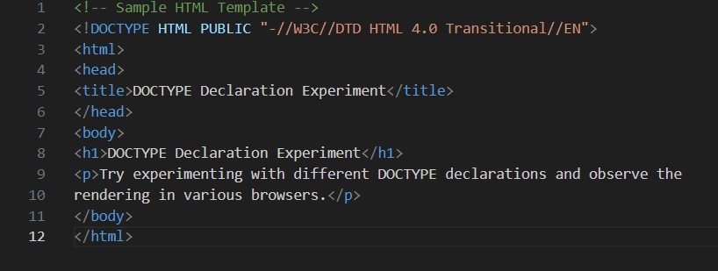

OUTPUT:

